

**SESSION : 2013-14**

**INFORMATICS PRACTICES PROJECT**

**TOPIC- CAFÉ COFFEE DAY**

**NAME : SHIVAM KUMAR SINGH**

**CLASS : XII “A”**

**ROLL NO : 29**



**cERTIFICATE**

**This is to certify that Shivam Kumar Singh of class XII ‘Science’ has successfully completed his/her Project in Informatics Practices as prescribed by the C.B.S.E., Year: 2013-2014.**

**Name of student : Shivam Kumar Singh**

**Class : XII ‘Science’**

**Roll No : 29**

**Name of the school: ARMY PUBLIC SCHOOL KIRKEE**

**Head of Department :-____________________**

**(Mrs. Sandhya Lad)**

**PRINCIPAL :-____________________**

**(Mrs. Preeti Khanna)**

**EXTERNAL EXAMINER :-____________________**

**Acknowledgement**

I wish to thank Principal Mrs. Preeti Khanna for providing all necessary resources and facilities in the school without which it would not have been possible to complete the project.

I also wish to sincerely thank our Informatics Practices teacher Mrs. Sandhya Lad for her encouragement, guidance and suggestions which helped me to complete my project in due time.

**Name : SHIVAM**

**Roll No : 29**

**Content**

|  |  |
| --- | --- |
| Particulars | Page |
| Hardware and software requirements | 5 |
| Introduction | 6 |
| Welcome to ccd | 7 |
| User login | 7 |
| Loading | 8 |
| Ordering ccd items | 9 |
| Displaying ordered items | 11 |
| Billing address  Summary of ordered items  Online payment  Bibliography | 12  13  14  15 |

**Hardware & Software Requirements**

* **Microsoft Windows XP Professional SP3/Vista SP1/Windows 7 Professional:**

Processor: 2.6 GHz Intel Pentium IV or equivalent

Memory: 2 GB

Disk space: 1 GB of free disk space

* **Ubuntu 9.10:**

Processor: 2.6 GHz Intel Pentium IV or equivalent

Memory: 2 GB

Disk space: 850 MB of free disk space

* **Solaris OS version 10 (SPARC):**

Processor: UltraSPARC IIIi 1 GHz

Memory: 2 GB

Disk space: 850 MB of free disk space

* **Solaris OS version 10 (x86/x64 platform edition):**

Processor: AMD Opteron 1200 Series 2.8 GHz

Memory: 2 GB

Disk space: 850 MB of free disk space

* **OpenSolaris 2010.03 (x86/x64 platform edition):**

Processor: AMD Opteron 1200 Series 2.8 GHz

Memory: 2 GB

Disk space: 650 MB of free disk space

* **Macintosh OS X 10.6 Intel:**

Processor: Dual-Core Intel (32 or 64-bit)

Memory: 2 GB

Disk space: 850 MB of free disk space

# Softwares Required

JDK 6 Update 13 or later.

**Introduction**

Cafés have been established as staples of society in industrialized nations throughout the world. While many may overlook the impact of the café on society, there is no doubt that its contributions have been large. Patrons frequent coffee shops, making a stop at the local Starbucks part of their daily routine. Cafés offer a pick-me-up before work, a reward after a long day, a stimulating environment for creativity and thought, or simply a place to relax and spend time with friends. An investigation of this salient place type offers insight into how and why cafés have become what they are today. An exploration of the goals and successes of coffee shops provide guidelines for the optimal functioning of future cafés.

Centuries later, cafés were introduced to America. The creation of Starbucks accounts for the establishment of a café culture in the United States. Having observed the workings of coffee shops in Europe, Gordon Bowker, Zev Siegl, and Jerry Baldwin brought the concept back to Seattle. Frustrated by the difficulty in obtaining a decent cup of coffee, they hoped to provide the community with easier access to this good. Their humble beginnings consisted of a small shop that was opened for business in 1971 (Clark, 40-42). It did not take long for this venture to expand. In 1989, only 585 coffee shops existed in the nation. Gaining support rapidly, Starbucks went public in 1992. By 2007, the number of coffee shops had grown to over 25,000 (9-10). The introduction of Starbucks to American society sparked a trend that has only grown since.

Despite the wide range of sub-types of cafés, they share similar goals. As with any business, cost is a concern. Maximizing profits and minimizing costs is the ultimate goal. This desired outcome influences the construction and design of each store as well as the price of goods (Clark, 110).

The goals of cafés primarily revolve around the customer. Coffee shops would not be successful without meeting user needs and subsequently establishing a customer base. Satisfaction surveys found that customers place more emphasis on having a good experience rather than enjoying a good cup of coffee (Agrawal, 254). As a result, “experience selling” emerged as a priority in creating cafés. Many patrons spend considerable amounts of time in the establishment during their visit. As a result, comfort is key. Because customers have a range of individual preferences, it is essential to provide a neutral public space, which satisfies a number of needs (256). Designers must account for the fact that some customers hope to gather in groups while others desire personal space. Regardless, customers expect a certain level of privacy. Therefore, another goal of cafés is to create a sense of both personal space and privacy (Grafe et al., 95). The goals of cafés are centered primarily around the customer. They aim to establish a balance between meeting the universal desires of patrons, such as comfort and privacy, and accounting for individual differences in user needs, such as independent workspaces.

Specific design choices support cafés’ ultimate goal of customer satisfaction. Atmosphere is of central concern. Depending on location and the target population, color, lighting, and music are manipulated (Agrawal, 254). As customers desire comfort when settling down in cafés, the

implementation of lounge chairs is beneficial. On the other hand, some prefer more rigid seating as they intend to focus on work. Therefore, a mix of furniture that can accommodate for different customers’ wants and needs proves most successful. To account for privacy, the visual accessibility and acoustics of the space should be considered (Grafe et al., 94-95). Finally, designers can meet the goal of creating a sense of community and belongingness by taking into account the elements of homeyness and stimulation. The goals of cafés can most easily be met through detailed design layouts.

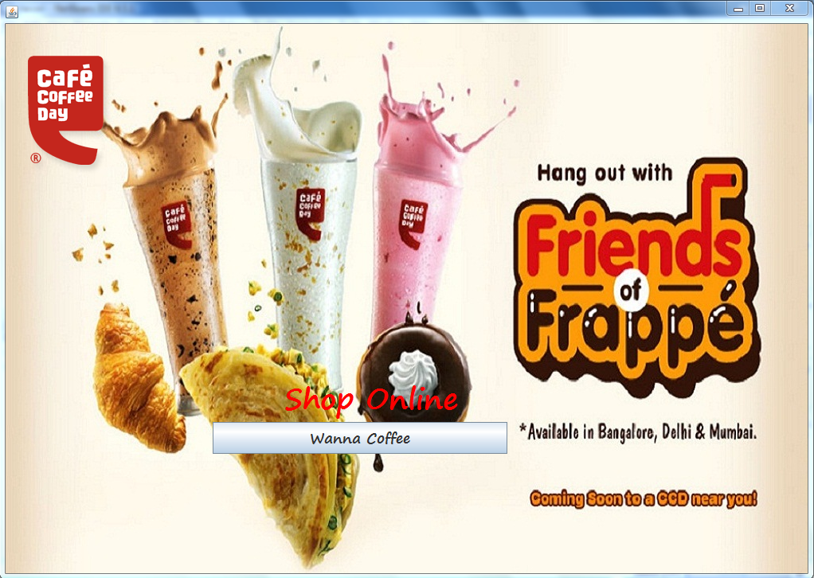

private void jButton1ActionPerformed(java.awt.event.ActionEvent evt) {

jFrame2.setVisible(true);

}

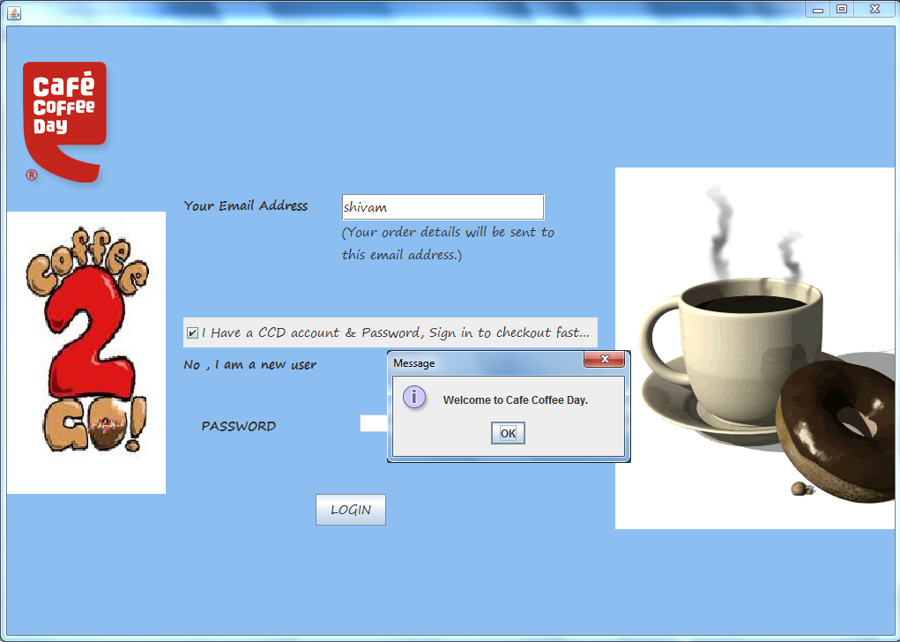

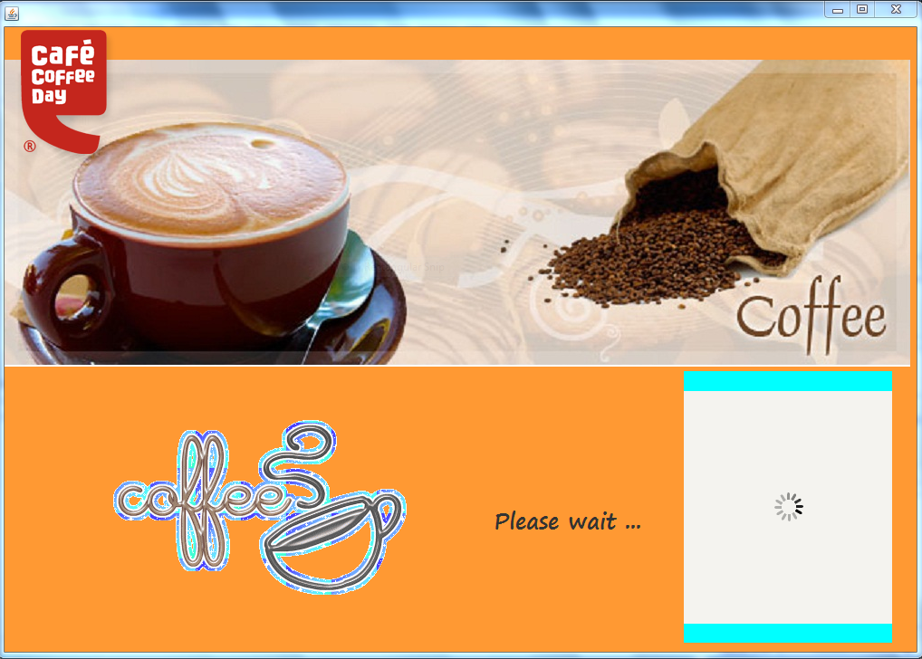

Connection con=null;

Statement stmt =null;

ResultSet rs = null;

private void jButton2ActionPerformed(java.awt.event.ActionEvent evt)

String a= jTextField1.getText();

String b=new String(jPasswordField1.getPassword());

try

{ Class.forName("java.sql.Driver");

con=DriverManager.getConnection("jdbc:mysql://localhost/logid","root","tiger");

stmt =con.createStatement();

String query="select * from ccday where eid = '"+a+"';";

rs=stmt.executeQuery(query);

if(rs.next())

{ JOptionPane.showMessageDialog(null,"Welcome to Cafe Coffee Day.");

Timer t=new Timer(500,new ActionListener()

{

public void actionPerformed(ActionEvent e)

{

l--;

switch(l)

{

case -6:jFrame1.setVisible(true);

break;

case -2:

jLabel51.setIcon(new ImageIcon("D:\\animated coffee\\coffee.gif"));

break;

case 4:

jLabel51.setIcon(newImageIcon("D:\\animatedcoffee\\tumblr_lyxi4ntnRE1r5few5o1_400.gif"));

break;

case 9:jFrame7.setVisible(true);

jLabel51.setIcon(newImageIcon("D:\\animatedcoffee\\tumblr_mdywnpuFYp1riahx7o1_500.gif"));

break;

}

}

}

);

t.start();

}

else

{JOptionPane.showMessageDialog(null,"Please enter your password.");

String quer="update ccday set eid = '"+a+"', pass = '"+"';";

stmt.executeUpdate(quer);

}

}

catch(Exception e)

{

JOptionPane.showMessageDialog(null,"Error In Connectivity");

}

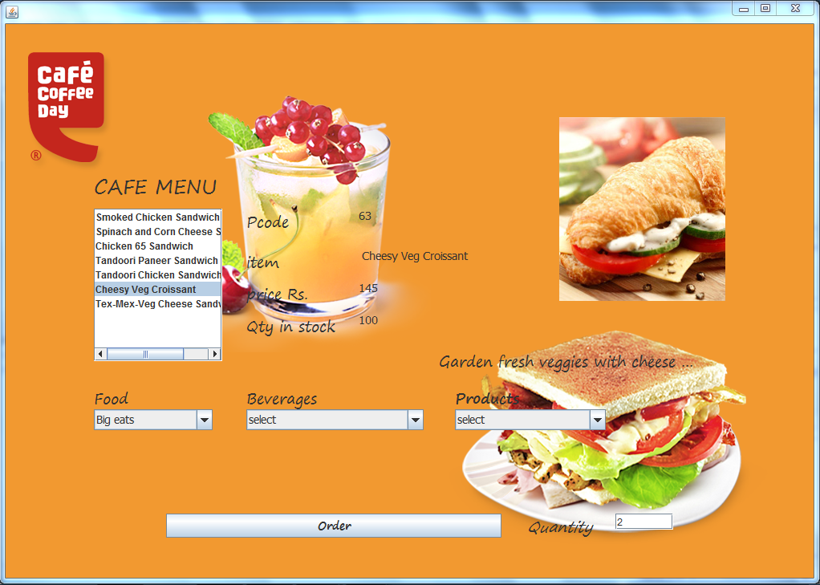

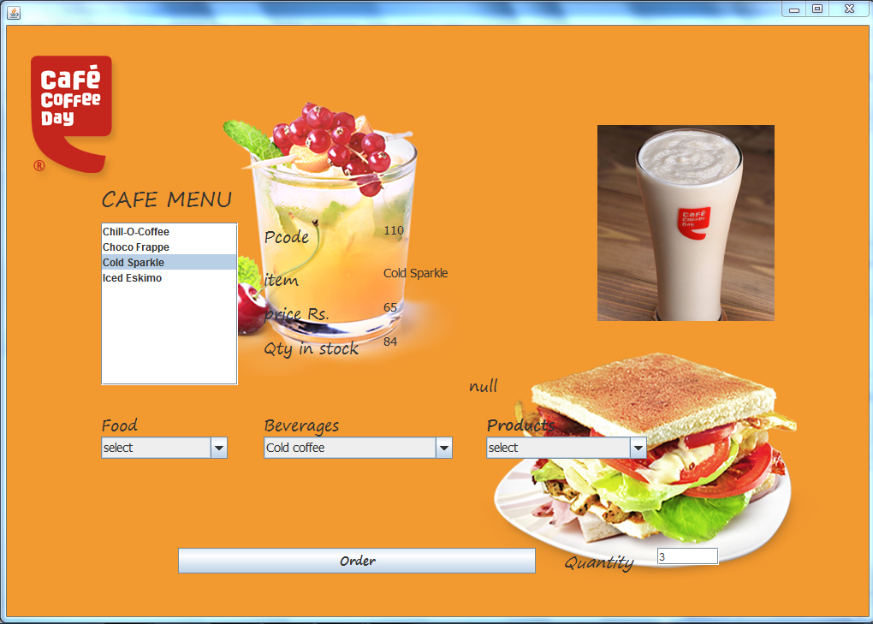

private void jList1MouseClicked(java.awt.event.MouseEvent evt) {

// TODO add your handling code here:

int a=jComboBox2.getSelectedIndex();

int b=jList1.getSelectedIndex();

switch(a){

case 1:

if(b==0){

jLabel9.setIcon(new ImageIcon("D:\\ccd\\Dessert Shots - CCD menu, find your favorite Mango Shot, Belgian Chocolate Shot and more._files\\ccd-mango-shot.jpg"));

jLabel44.setText(" Mango Shot");

jLabel43.setText("50");

jLabel8.setText("96");

jLabel38.setText("100");

jLabel32.setText("A Luscious and creamy Alphonso mango delight ");

}else

if(b==1){

jLabel9.setIcon(new ImageIcon("D:\\ccd\\Dessert Shots - CCD menu, find your favorite Mango Shot, Belgian Chocolate Shot and more._files\\ccd-belgian-choco-shot.jpg"));

jLabel44.setText(" Belgian Choco Shot");

jLabel43.setText("51");

jLabel8.setText("80");

jLabel38.setText("100");

jLabel32.setText("A rich smooth Belgian chocolate shot ");

}

break;

case 2:

if(b==0)

{ jLabel9.setIcon(new ImageIcon("D:\\ccd\\Small Eats - CCD Menu card, find veg puff, chicken puff, cheese toast, cookies, samosa and more._files\\ccd-veg-samosa.JPG"));

jLabel44.setText(" Veg Samosa");

jLabel43.setText("52");

jLabel8.setText("20");

jLabel38.setText("100");

jLabel32.setText("Potatoes and pea cooked in traditional Indian ... ");

} else

if(b==1)

{ jLabel9.setIcon(new ImageIcon("D:\\ccd\\Small Eats - CCD Menu card, find veg puff, chicken puff, cheese toast, cookies, samosa and more._files\\ccd-hot-n-spicy-chicken-puff.jpg"));

jLabel44.setText(" Hot and Spicy Chicken Puff");

jLabel43.setText("53");

jLabel8.setText("45");

jLabel38.setText("96");

jLabel32.setText("null");

} else

if(b==2)

{ jLabel9.setIcon(new ImageIcon("D:\\ccd\\Small Eats - CCD Menu card, find veg puff, chicken puff, cheese toast, cookies, samosa and more._files\\ccd-chilli-cheese-toast.jpg"));

jLabel44.setText(" Chilli Cheese Toast ");

jLabel43.setText("54");

jLabel8.setText("65");

jLabel38.setText("84");

jLabel32.setText("null");

} else

if(b==3)

{ jLabel9.setIcon(new ImageIcon("D:\\ccd\\Small Eats - CCD Menu card, find veg puff, chicken puff, cheese toast, cookies, samosa and more._files\\ccd-choco-chip-cookie.jpg"));

jLabel44.setText(" Cookie ");

jLabel43.setText("55");

jLabel8.setText("55");

jLabel38.setText("96");

jLabel32.setText("Twin packs available in Blackcurrant, Double Choc... ");

}else

if(b==4)

{ jLabel9.setIcon(new ImageIcon("D:\\ccd\\Small Eats - CCD Menu card, find veg puff, chicken puff, cheese toast, cookies, samosa and more._files\\ccd-hot-n-spicy-veg-puff.jpg"));

jLabel44.setText(" Hot and Spicy Veg Puff ");

jLabel43.setText("56");

jLabel8.setText("98");

jLabel38.setText("78");

jLabel32.setText("Crunchy veggies tossed in spicy sauce, wrapped in... ");

} break;

case 3:

if(b==0)

{ jLabel9.setIcon(new ImageIcon("D:\\ccd\\Sandwich CCD - Chicken 65, tandoori paneer, tex-mex-veg cheese, cheesy veg croissant and much more._files\\ccd-smoked-chicken-sandwich.jpg"));

jLabel44.setText(" Smoked Chicken Sandwich ");

jLabel43.setText("57");

jLabel8.setText("145");

jLabel38.setText("100");

jLabel32.setText("Succulent smoked chicken topped with crunchy vegg... ");

} else

if(b==1)

{ jLabel9.setIcon(new ImageIcon("D:\\ccd\\Sandwich CCD - Chicken 65, tandoori paneer, tex-mex-veg cheese, cheesy veg croissant and much more._files\\ccd-spinach-corn-cheese-sandwich.jpg"));

jLabel44.setText(" Spinach and Corn Cheese Sandwich ");

jLabel43.setText("58");

jLabel8.setText("120");

jLabel38.setText("100");

jLabel32.setText("null ");

} else

if(b==2)

{ jLabel9.setIcon(new ImageIcon("D:\\ccd\\Sandwich CCD - Chicken 65, tandoori paneer, tex-mex-veg cheese, cheesy veg croissant and much more._files\\ccd-chicken-65.jpg"));

jLabel44.setText(" Chicken 65 Sandwich ");

jLabel43.setText("59");

jLabel8.setText("120");

jLabel38.setText("100");

jLabel32.setText("null ");

} else

if(b==3)

{ jLabel9.setIcon(new ImageIcon("D:\\ccd\\Sandwich CCD - Chicken 65, tandoori paneer, tex-mex-veg cheese, cheesy veg croissant and much more._files\\ccd-tandoori-paneer-sandwich.jpg"));

jLabel44.setText(" Tandoori Paneer Sandwich ");

jLabel43.setText("60");

jLabel8.setText("140");

jLabel38.setText("120");

jLabel32.setText("Tandoori paneer with chatpata salad, served in a ... ");

} else

if(b==4)

{ jLabel9.setIcon(new ImageIcon("D:\\ccd\\Sandwich CCD - Chicken 65, tandoori paneer, tex-mex-veg cheese, cheesy veg croissant and much more._files\\ccd-tandoori-chicken-sandwich.jpg"));

jLabel44.setText(" Tandoori Chicken Sandwich ");

jLabel43.setText("62");

jLabel8.setText("120");

jLabel38.setText("58");

jLabel32.setText("Tandoori chicken with chatpata tomatoes, wrapped ... ");

} else

if(b==5)

{ jLabel9.setIcon(new ImageIcon("D:\\ccd\\Sandwich CCD - Chicken 65, tandoori paneer, tex-mex-veg cheese, cheesy veg croissant and much more._files\\ccd-cheesy-veg-croissant.jpg"));

jLabel44.setText(" Cheesy Veg Croissant ");

jLabel43.setText("63");

jLabel8.setText("145");

jLabel38.setText("100");

jLabel32.setText("Garden fresh veggies with cheese wrapped in a sof... ");

} else

if(b==6)

{ jLabel9.setIcon(new ImageIcon("D:\\ccd\\Sandwich CCD - Chicken 65, tandoori paneer, tex-mex-veg cheese, cheesy veg croissant and much more._files\\ccd-tex-mex-veg-cheese-sandwich.jpg"));

jLabel44.setText(" Tex-Mex-Veg Cheese Sandwich ");

jLabel43.setText("64");

jLabel8.setText("120");

jLabel38.setText("45");

jLabel32.setText("Veggies tossed in chilli salsa andcheese, wrappe... ");

}break;

case 4:

if(b==0)

{ jLabel9.setIcon(new ImageIcon("D:\\ccd\\Sweet Treats - Find your black forest cake, rich chocolate cake, brownie and indulgence from CCD._files\\ccd-black-forest-cup.jpg"));

jLabel44.setText(" Black Forest Cup ");

jLabel43.setText("65");

jLabel8.setText("130");

jLabel38.setText("63");

jLabel32.setText("The classic Black Forest cake served in a cup....");

} else

if(b==1)

{ jLabel9.setIcon(new ImageIcon("D:\\ccd\\Sweet Treats - Find your black forest cake, rich chocolate cake, brownie and indulgence from CCD._files\\ccd-chocolate-fantasy.jpg"));

jLabel44.setText(" Chocolate Fantasy ");

jLabel43.setText("66");

jLabel8.setText("120");

jLabel38.setText("45");

jLabel32.setText("null ");

} else

if(b==2)

{ jLabel9.setIcon(new ImageIcon("D:\\ccd\\Sweet Treats - Find your black forest cake, rich chocolate cake, brownie and indulgence from CCD._files\\ccd-nutty-fudge-brownie.jpg"));

jLabel44.setText("Nutty Fudge Brownie");

jLabel43.setText("67");

jLabel8.setText("100");

jLabel38.setText("67");

jLabel32.setText("null ");

} else

if(b==3)

{ jLabel9.setIcon(new ImageIcon("D:\\ccd\\Sweet Treats - Find your black forest cake, rich chocolate cake, brownie and indulgence from CCD._files\\ccd-cafe-coffee-day-indulgence.jpg"));

jLabel44.setText("Cafe Coffee Day Indulgence ");

jLabel43.setText("68");

jLabel8.setText("150");

jLabel38.setText("30");

jLabel32.setText("Our signature chocolate cake that oozes indulgenc... ");

} break;

case 5:

if(b==0)

{ jLabel9.setIcon(new ImageIcon("D:\\ccd\\Sundaes - CCD Menu. Find brownie, fruity blizz, chocolate cake, vanilla ice cream, choco hola & more_files\\ccd-choco-hola.jpg"));

jLabel44.setText("Choc-Hola ");

jLabel43.setText("69");

jLabel8.setText("79");

jLabel38.setText("54");

jLabel32.setText("Rich chocolate cake with scoops ofvanilla ice cr... ");

}else

if(b==1)

{ jLabel9.setIcon(new ImageIcon("D:\\ccd\\Sundaes - CCD Menu. Find brownie, fruity blizz, chocolate cake, vanilla ice cream, choco hola & more_files\\ccd-dark-passion.jpg"));

jLabel44.setText("Dark Passion");

jLabel43.setText("104");

jLabel8.setText("189");

jLabel38.setText("80");

jLabel32.setText("null");

}else

if(b==2)

{ jLabel9.setIcon(new ImageIcon("D:\\ccd\\Sundaes - CCD Menu. Find brownie, fruity blizz, chocolate cake, vanilla ice cream, choco hola & more_files\\ccd-sizzle-dazzle-brownie.jpg"));

jLabel44.setText("Sizzle Dazzle Brownie");

jLabel43.setText("105");

jLabel8.setText("75");

jLabel38.setText("25");

jLabel32.setText("null");

} break;

case 6:

if(b==0)

{ jLabel9.setIcon(new ImageIcon("D:\\ccd\\Cakes CCD - Order Chocolate Fantasy cake and make special occasions, parties, events unforgettable._files\\ccd-chocolate-fantasy-cake.jpg"));

jLabel44.setText("Chocolate Fantasy Cake ");

jLabel43.setText("109");

jLabel8.setText("299");

jLabel38.setText("2");

jLabel32.setText("Order from our wide range of delicious cakes and ... ");

} break;

}

int f=jComboBox6.getSelectedIndex();

switch(f)

{

case 1:

if(b==0)

{ jLabel9.setIcon(new ImageIcon("D:\\ccd\\Coffee - Find Cappuccino, Cafe Latte, Espresso, Macchiato, Cafe Mocha, Chococcino, Black Irish Coffee._files\\ccd-black-coffee.jpg"));

jLabel44.setText("Black Coffee ");

jLabel43.setText("70");

jLabel8.setText("70");

jLabel38.setText("120");

jLabel32.setText("null");

} else

if(b==1)

{ jLabel9.setIcon(new ImageIcon("D:\\ccd\\Coffee - Find Cappuccino, Cafe Latte, Espresso, Macchiato, Cafe Mocha, Chococcino, Black Irish Coffee._files\\ccd-cafe-latte.jpg"));

jLabel44.setText("Cafe latte");

jLabel43.setText("71");

jLabel8.setText("75");

jLabel38.setText("45");

jLabel32.setText("null");

} else

if(b==2)

{ jLabel9.setIcon(new ImageIcon("D:\\ccd\\Coffee - Find Cappuccino, Cafe Latte, Espresso, Macchiato, Cafe Mocha, Chococcino, Black Irish Coffee._files\\ccd-cappuccino.jpg"));

jLabel44.setText("Cappuccino");

jLabel43.setText("72");

jLabel8.setText("60");

jLabel38.setText("96");

jLabel32.setText("null");

} else

if(b==3)

{ jLabel9.setIcon(new ImageIcon("D:\\ccd\\Coffee - Find Cappuccino, Cafe Latte, Espresso, Macchiato, Cafe Mocha, Chococcino, Black Irish Coffee._files\\ccd-chococinno.jpg"));

jLabel44.setText("Chococcino");

jLabel43.setText("73");

jLabel8.setText("60");

jLabel38.setText("96");

jLabel32.setText("null");

} else

if(b==4)

{ jLabel9.setIcon(new ImageIcon("D:\\ccd\\Coffee - Find Cappuccino, Cafe Latte, Espresso, Macchiato, Cafe Mocha, Chococcino, Black Irish Coffee._files\\ccd-espresso.jpg"));

jLabel44.setText("Espresso");

jLabel43.setText("74");

jLabel8.setText("52");

jLabel38.setText("20");

jLabel32.setText("null");

}

break;

case 2:if(b==0)

{jLabel9.setIcon(new ImageIcon("D:\\ccd\\Cold Coffee - CCD menu card to find your iced coffee, frappe, chocolate coffee, creamy coffee and more._files\\ccd-chill-o-coffee.jpg"));

jLabel44.setText("Chill-O-Coffee");

jLabel43.setText("118");

jLabel8.setText("50");

jLabel38.setText("47");

jLabel32.setText("null");

} else

if(b==1)

{ jLabel9.setIcon(new ImageIcon("D:\\ccd\\Cold Coffee - CCD menu card to find your iced coffee, frappe, chocolate coffee, creamy coffee and more._files\\ccd-choco-frappe.jpg"));

jLabel44.setText("Choco Frappe");

jLabel43.setText("78");

jLabel8.setText("158");

jLabel38.setText("25");

jLabel32.setText("More chocolate and ice cream in rich cold coff...");

}else

if(b==2)

{ jLabel9.setIcon(new ImageIcon("D:\\ccd\\Cold Coffee - CCD menu card to find your iced coffee, frappe, chocolate coffee, creamy coffee and more._files\\ccd-cold-sparkle.jpg"));

jLabel44.setText("Cold Sparkle");

jLabel43.setText("110");

jLabel8.setText("65");

jLabel38.setText("84");

jLabel32.setText("null");

} else

if(b==3)

{ jLabel9.setIcon(new ImageIcon("D:\\ccd\\Cold Coffee - CCD menu card to find your iced coffee, frappe, chocolate coffee, creamy coffee and more._files\\ccd-iced-eskimo.jpg"));

jLabel44.setText("Iced Eskimo");

jLabel43.setText("79");

jLabel8.setText("65");

jLabel38.setText("89");

jLabel32.setText("Very rich, very cool with a strongcoffee edge...");

}

break;

case 3:if(b==0)

{ jLabel9.setIcon(new ImageIcon("D:\\ccd\\Tea - Cafe Menu, find your favorite Assam tea, green tea, Darjeeling tea, lemon tea, Indian masala chai here._files\\ccd-assam-tea.jpg"));

jLabel44.setText("Assam Tea");

jLabel43.setText("82");

jLabel8.setText("189");

jLabel38.setText("58");

jLabel32.setText("Only the finest tea leaves from Assam can give... ");

}else

if(b==1)

{ jLabel9.setIcon(new ImageIcon("D:\\ccd\\Tea - Cafe Menu, find your favorite Assam tea, green tea, Darjeeling tea, lemon tea, Indian masala chai here._files\\ccd-darjeeling-tea.jpg"));

jLabel44.setText("Darjeeling Tea");

jLabel43.setText("83");

jLabel8.setText("89");

jLabel38.setText("56");

jLabel32.setText("When a legend enters the French Press, things ... ");

} else

if(b==2)

{ jLabel9.setIcon(new ImageIcon("D:\\ccd\\Tea - Cafe Menu, find your favorite Assam tea, green tea, Darjeeling tea, lemon tea, Indian masala chai here._files\\ccd-masala-chai.jpg"));

jLabel44.setText("Masala Chai ");

jLabel43.setText("84");

jLabel8.setText("255");

jLabel38.setText("21");

jLabel32.setText("The Masala Chai is rich, balanced and full of ... ");

} else

if(b==3)

{ jLabel9.setIcon(new ImageIcon("D:\\ccd\\Tea - Cafe Menu, find your favorite Assam tea, green tea, Darjeeling tea, lemon tea, Indian masala chai here._files\\ccd-green-jasmine-tea.jpg"));

jLabel44.setText("Green Jasmine Tea");

jLabel43.setText("85");

jLabel8.setText("75");

jLabel38.setText("45");

jLabel32.setText("A Sweet, aromatic and healthy tea.The leaves ... ");

} break;

case 4:if(b==0)

{ jLabel9.setIcon(new ImageIcon("D:\\ccd\\Iced Tea - find lemon iced tea, strawberry tea, kiwi tea, flavored cold tea and more._files\\ccd-lemon-iced-tea.jpg"));

jLabel44.setText("Lemon Iced Tea");

jLabel43.setText("86");

jLabel8.setText("256");

jLabel38.setText("45");

jLabel32.setText("Ice cold, lemon flavoured tea, the ultimate refre... ");

}else

if(b==1)

{ jLabel9.setIcon(new ImageIcon("D:\\ccd\\Iced Tea - find lemon iced tea, strawberry tea, kiwi tea, flavored cold tea and more._files\\ccd-lychee-frost-tea.jpg"));

jLabel44.setText("Lychee frost tea");

jLabel43.setText("111");

jLabel8.setText("69");

jLabel38.setText("12");

jLabel32.setText("null ");

} else

if(b==2)

{ jLabel9.setIcon(new ImageIcon("D:\\ccd\\Iced Tea - find lemon iced tea, strawberry tea, kiwi tea, flavored cold tea and more._files\\ccd-strawberry-iced-tea.jpg"));

jLabel44.setText("Strawberry iced tea ");

jLabel43.setText("112");

jLabel8.setText("69");

jLabel38.setText("12");

jLabel32.setText("null");

} else

if(b==3)

{ jLabel9.setIcon(new ImageIcon("D:\\ccd\\Iced Tea - find lemon iced tea, strawberry tea, kiwi tea, flavored cold tea and more._files\\ccd-pomegranate-lemon.jpg"));

jLabel44.setText("Pomegranate Lemon");

jLabel43.setText("87");

jLabel8.setText("65");

jLabel38.setText("54");

jLabel32.setText("Lemon iced tea with crunchy pomegranate and delic...");

}

break;

case 5:if(b==0)

{ jLabel9.setIcon(new ImageIcon("D:\\ccd\\Chocoholicas - Find iced chocolate drinks, cold chocolate milkshake, choco rocks, latte and more._files\\ccd-choco-rocks.jpg"));

jLabel44.setText("Choco Rocks");

jLabel43.setText("90");

jLabel8.setText("256");

jLabel38.setText("74");

jLabel32.setText("Plunge into the bottomless layersof sinful choco...");

}else

if(b==1)

{ jLabel9.setIcon(new ImageIcon("D:\\ccd\\Chocoholicas - Find iced chocolate drinks, cold chocolate milkshake, choco rocks, latte and more._files\\ccd-cold-chocoholica.jpg"));

jLabel44.setText("Cold Chocoholica");

jLabel43.setText("113");

jLabel8.setText("96");

jLabel38.setText("45");

jLabel32.setText("null");

}else

if(b==2)

{ jLabel9.setIcon(new ImageIcon("D:\\ccd\\Chocoholicas - Find iced chocolate drinks, cold chocolate milkshake, choco rocks, latte and more._files\\ccd-gourmet-hot-chocolate.jpg"));

jLabel44.setText("Gourmet Hot Chocolate");

jLabel43.setText("114");

jLabel8.setText("80");

jLabel38.setText("54");

jLabel32.setText("null");

} break;

case 6:if(b==0)

{ jLabel9.setIcon(new ImageIcon("D:\\ccd\\Fruiteazers - Find mango milkshake, strawberry blush, green apple soda, cool blue, black currant blast_files\\ccd-black-currant-blast.jpg"));

jLabel44.setText("Black Currant Blast");

jLabel43.setText("91");

jLabel8.setText("63");

jLabel38.setText("36");

jLabel32.setText("Black currant flavoured milkshake blended with ic... ");

} else

if(b==1)

{ jLabel9.setIcon(new ImageIcon("D:\\ccd\\Fruiteazers - Find mango milkshake, strawberry blush, green apple soda, cool blue, black currant blast_files\\ccd-cool-blue.jpg"));

jLabel44.setText("Cool Blue");

jLabel43.setText("92");

jLabel8.setText("78");

jLabel38.setText("120");

jLabel32.setText("Bright blue and tangy ice slush.");

} else

if(b==2)

{ jLabel9.setIcon(new ImageIcon("D:\\ccd\\Fruiteazers - Find mango milkshake, strawberry blush, green apple soda, cool blue, black currant blast_files\\ccd-green-apple-soda.jpg"));

jLabel44.setText("Green Apple Soda");

jLabel43.setText("115");

jLabel8.setText("60");

jLabel38.setText("5");

jLabel32.setText("null");

} else

if(b==3)

{ jLabel9.setIcon(new ImageIcon("D:\\ccd\\Fruiteazers - Find mango milkshake, strawberry blush, green apple soda, cool blue, black currant blast_files\\ccd-lychee-chill.jpg"));

jLabel44.setText("Lychee Chill ");

jLabel43.setText("93");

jLabel8.setText("125");

jLabel38.setText("50");

jLabel32.setText("Delight in the lusciousness of lychee in a smooth...");

}

break;

case 7:if(b==0)

{ jLabel9.setIcon(new ImageIcon("D:\\ccd\\Quenchers - Find mango, pomegranate, tangy, kiwi, green apple, lemon flavored fruit drinks._files\\ccd-snapple-1.jpg"));

jLabel44.setText("Snapple ");

jLabel43.setText("45");

jLabel8.setText("25");

jLabel38.setText("45");

jLabel32.setText("Available in Raspberry Cranberry, Mango madness &... ");

} else

if(b==1)

{ jLabel9.setIcon(new ImageIcon("D:\\ccd\\Quenchers - Find mango, pomegranate, tangy, kiwi, green apple, lemon flavored fruit drinks._files\\ccd-wtf-mango.jpg"));

jLabel44.setText(" Mushy Mango");

jLabel43.setText("97");

jLabel8.setText("80");

jLabel38.setText("30");

jLabel32.setText("Enriched with the goodness of mango, The drink is...");

} else

if(b==2)

{ jLabel9.setIcon(new ImageIcon("D:\\ccd\\Quenchers - Find mango, pomegranate, tangy, kiwi, green apple, lemon flavored fruit drinks._files\\ccd-wtf-pom.jpg"));

jLabel44.setText("Pome Cherry");

jLabel43.setText("116");

jLabel8.setText("85");

jLabel38.setText("5");

jLabel32.setText("null");

} else

if(b==3)

{ jLabel9.setIcon(new ImageIcon("D:\\ccd\\Quenchers - Find mango, pomegranate, tangy, kiwi, green apple, lemon flavored fruit drinks._files\\ccd-wtf-tangy.jpg"));

jLabel44.setText("Tangy Fushion ");

jLabel43.setText("98");

jLabel8.setText("120");

jLabel38.setText("20");

jLabel32.setText("This juice is the mishmash of Kiwi,Green apple a... ");

}

break;

case 8:if(b==0)

{ jLabel9.setIcon(new ImageIcon("D:\\ccd\\International Coffee - Aztec, Ethiopian. American gourmet blends, brewed from premium coffee beans._files\\ccd-aztec.jpg"));

jLabel44.setText("Aztec");

jLabel43.setText("100");

jLabel8.setText("156");

jLabel38.setText("56");

jLabel32.setText("A delightful American coffee blend.Internatio... ");

}else

if(b==1)

{ jLabel9.setIcon(new ImageIcon("D:\\ccd\\International Coffee - Aztec, Ethiopian. American gourmet blends, brewed from premium coffee beans._files\\ccd-ethiopian.jpg"));

jLabel44.setText("Ethiopian");

jLabel43.setText("117");

jLabel8.setText("65");

jLabel38.setText("8");

jLabel32.setText("null");

} break;

case 9:if(b==0)

{ jLabel9.setIcon(new ImageIcon("D:\\ccd\\Lemonades - Strawberry, Kiwi, Mint flavored Classic lemon drinks for this summer._files\\ccd-strawberry-lemonade.jpg"));

jLabel44.setText("Strawberry Lemonade");

jLabel43.setText("101");

jLabel8.setText("90");

jLabel38.setText("47");

jLabel32.setText("Luscious strawberry lemonade with flavourful b... ");

} else

if(b==1)

{ jLabel9.setIcon(new ImageIcon("D:\\ccd\\Lemonades - Strawberry, Kiwi, Mint flavored Classic lemon drinks for this summer._files\\ccd-kiwi-lemonade.jpg"));

jLabel44.setText("Kiwi Lemonade");

jLabel43.setText("102");

jLabel8.setText("148");

jLabel38.setText("53");

jLabel32.setText("Zesty kiwi infused lemonade, spicedwith flavo... ");

} else

if(b==2)

{ jLabel9.setIcon(new ImageIcon("D:\\ccd\\Lemonades - Strawberry, Kiwi, Mint flavored Classic lemon drinks for this summer._files\\ccd-classic-lemonade.jpg"));

jLabel44.setText("Classic Lemonade");

jLabel43.setText("103");

jLabel8.setText("189");

jLabel38.setText("80");

jLabel32.setText("Refreshing lemonade with a touch ofmint and g... ");

}break;

}

int g=jComboBox7.getSelectedIndex();

switch(g)

{

case 1:

if(b==0)

{ jLabel9.setIcon(new ImageIcon("D:\\ccd\\Buy Coffee Powders - Cafe offee Day_files\\ccd-pure-arabica-estate-blend.jpg"));

jLabel44.setText("Wakecup");

jLabel43.setText("119");

jLabel8.setText("67");

jLabel38.setText("78");

jLabel32.setText("null");

}else

if(b==1)

{ jLabel9.setIcon(new ImageIcon("D:\\ccd\\Shop Online - buy coffee maker, espresso maker, coffee powder, mugs, cups, gift cards and much more._files\\coffee-maker.jpg"));

jLabel44.setText("Stovetop Espresso Maker");

jLabel43.setText("120");

jLabel8.setText("75");

jLabel38.setText("78");

jLabel32.setText("null");

} break;

case 2:

if(b==0)

{ jLabel9.setIcon(new ImageIcon("D:\\ccd\\Buy Coffee Powders - Cafe offee Day_files\\ccd-Drizzle-Chicory-(Pack-of-2)-Now-Filta-Fresh.jpg"));

jLabel44.setText("Drizzle(Chicory blended coffe...");

jLabel43.setText("121");

jLabel8.setText("78");

jLabel38.setText("98");

jLabel32.setText("null");

} else

if(b==1)

{ jLabel9.setIcon(new ImageIcon("D:\\ccd\\Buy Coffee Powders - Cafe offee Day_files\\ccd-Drizzle-Pure-(Pack-of-2)-Now-Filta-Fresh.png"));

jLabel44.setText("Drizzle Pure (Pack of 2) - No...");

jLabel43.setText("122");

jLabel8.setText("85");

jLabel38.setText("47");

jLabel32.setText("null");

}else

if(b==2)

{ jLabel9.setIcon(new ImageIcon("D:\\ccd\\Buy Coffee Powders - Cafe offee Day_files\\ccd-mysore-nuggets.jpg"));

jLabel44.setText("Mysore Nuggets Extra Bold");

jLabel43.setText("123");

jLabel8.setText("45");

jLabel38.setText("87");

jLabel32.setText("null");

} else

if(b==3)

{ jLabel9.setIcon(new ImageIcon("D:\\ccd\\Buy Coffee Powders - Cafe offee Day_files\\ccd-indian-kathlekhan.jpg"));

jLabel44.setText("Indian Kathlekhan Superior");

jLabel43.setText("124");

jLabel8.setText("77");

jLabel38.setText("99");

jLabel32.setText("null");

} break;

case 3:

if(b==0)

{ jLabel9.setIcon(new ImageIcon("D:\\ccd\\Shop Online - buy coffee maker, espresso maker, coffee powder, mugs, cups, gift cards and much more._files\\quick-bites.jpg"));

jLabel44.setText("Cookies");

jLabel43.setText("125");

jLabel8.setText("88");

jLabel38.setText("98");

jLabel32.setText("null");

} else

if(b==1)

{ jLabel9.setIcon(new ImageIcon("D:\\ccd\\Shop Online - buy coffee maker, espresso maker, coffee powder, mugs, cups, gift cards and much more._files\\quick-bites.jpg"));

jLabel44.setText("Chocolates");

jLabel43.setText("126");

jLabel8.setText("78");

jLabel38.setText("100");

jLabel32.setText("null");

} break;

}

}

private void jComboBox2ActionPerformed(java.awt.event.ActionEvent evt) {

// TODO add your handling code here:

/*

Dessert Shots

Small eats

Big eats

Sweet Treats

Sundaes

Cake away

*/

int a=jComboBox2.getSelectedIndex();

DefaultListModel b=(DefaultListModel)jList1.getModel();

switch(a){

case 0:b.removeAllElements();

jLabel9.setIcon(new ImageIcon(""));

jLabel44.setText("");

jLabel43.setText("");

jLabel8.setText("");

jLabel38.setText("");

jLabel32.setText("");

break;

case 1:b.removeAllElements();

b.addElement("Mango Shot");

b.addElement("Belgian Choco Shot");

jList1.setModel(b);

break;

case 2:

b.removeAllElements();

b.addElement("Veg Samosa");

b.addElement("Hot and Spicy Chicken Puff ");

b.addElement("Chilli Cheese Toast ");

b.addElement("Cookie");

b.addElement("Hot and Spicy Veg Puff ");

jList1.setModel(b);

break;

case 3:

b.removeAllElements();

b.addElement("Smoked Chicken Sandwich");

b.addElement("Spinach and Corn Cheese Sandwich");

b.addElement("Chicken 65 Sandwich");

b.addElement("Tandoori Paneer Sandwich");

b.addElement("Tandoori Chicken Sandwich ");

b.addElement("Cheesy Veg Croissant");

b.addElement("Tex-Mex-Veg Cheese Sandwich");

jList1.setModel(b);

break;

case 4:

b.removeAllElements();

b.addElement("Black Forest Cup");

b.addElement("Chocolate Fantasy");

b.addElement("Nutty Fudge Brownie ");

b.addElement("Cafe Coffee Day Indulgence");

jList1.setModel(b);

break;

case 5:

b.removeAllElements();

b.addElement("Choc-Hola");

b.addElement("Dark Passion");

b.addElement("Sizzle Dazzle Brownie");

jList1.setModel(b);

break;

case 6:

b.removeAllElements();

b.addElement("Chocolate Fantasy Cake");

jList1.setModel(b);

break;

}

}

private void jComboBox6ActionPerformed(java.awt.event.ActionEvent evt) {

// TODO add your handling code here:

/*

Hot coffee

Cold coffee

Hoteas

Frosteas

Chocoholicas

Fruiteazers

Quenchers

International coffee

Lemonades

*/

int a=jComboBox6.getSelectedIndex();

DefaultListModel b=(DefaultListModel)jList1.getModel();

switch(a){

case 0:b.removeAllElements();

jLabel9.setIcon(new ImageIcon(""));

jLabel44.setText("");

jLabel43.setText("");

jLabel8.setText("");

jLabel38.setText("");

jLabel32.setText("");

break;

case 1:

b.removeAllElements();

b.addElement("Black Coffee");

b.addElement("Cafe latte");

b.addElement("Cappuccino");

b.addElement("Chococcino");

b.addElement("Espresso");

break;

case 2:

b.removeAllElements();

b.addElement("Chill-O-Coffee");

b.addElement("Choco Frappe");

b.addElement("Cold Sparkle");

b.addElement("Iced Eskimo");

break;

case 3:

b.removeAllElements();

b.addElement("Assam Tea");

b.addElement("Darjeeling Tea");

b.addElement("Masala Chai");

b.addElement("Green Jasmine Tea");

break;

case 4:

b.removeAllElements();

b.addElement("Lemon Iced Tea");

b.addElement("Lychee frost tea");

b.addElement("Strawberry iced tea");

b.addElement("Pomegranate Lemon");

break;

case 5:

b.removeAllElements();

b.addElement("Choco Rocks");

b.addElement("Cold Chocoholica");

b.addElement("Gourmet Hot Chocolate");

break;

case 6:

b.removeAllElements();

b.addElement("Black Currant Blast");

b.addElement("Cool Blue");

b.addElement("Green Apple Soda");

b.addElement("Lychee Chill");

break;

case 7:

b.removeAllElements();

b.addElement("Snapple");

b.addElement("Mushy Mango");

b.addElement("Pome Cherry");

b.addElement("Tangy Fushion");

break;

case 8:

b.removeAllElements();

b.addElement("Aztec");

b.addElement("Ethiopian");

break;

case 9:

b.removeAllElements();

b.addElement("Strawberry Lemonade");

b.addElement("Kiwi Lemonade");

b.addElement("Classic Lemonade");

break;

}jList1.setModel(b);

}

private void jComboBox7ActionPerformed(java.awt.event.ActionEvent evt) {

// TODO add your handling code here:

/*

Coffee Maker

Coffee Powders

Quick Bites

*/

int a=jComboBox7.getSelectedIndex();

DefaultListModel b=(DefaultListModel)jList1.getModel();

switch(a){

case 0:b.removeAllElements();

jLabel9.setIcon(new ImageIcon(""));

jLabel44.setText("");

jLabel43.setText("");

jLabel8.setText("");

jLabel38.setText("");

jLabel32.setText("");

break;

case 1:

b.removeAllElements();

b.addElement("Wakecup");

b.addElement("Stovetop Espresso Maker");

break;

case 2:

b.removeAllElements();

b.addElement("Drizzle(Chicory blended coffe...");

b.addElement("Drizzle Pure (Pack of 2) - No...");

b.addElement("Mysore Nuggets Extra Bold");

b.addElement("Indian Kathlekhan Superior");

break;

case 3:

b.removeAllElements();

b.addElement("Cookies");

b.addElement("Chocolates");

break;

}jList1.setModel(b);

}

private void jButton4ActionPerformed(java.awt.event.ActionEvent evt)

int a=Integer.parseInt(jLabel38.getText());

int s=Integer.parseInt(jTextField9.getText());

if(s>a)

JOptionPane.showMessageDialog(null,"only "+a+" items of "+jLabel43.getText()+" are in stock ! \n Sorry cannot take your order.");

else

{

int amt = s * Integer.parseInt(jLabel8.getText());

int t = Integer.parseInt(jLabel41.getText());

DefaultTableModel model=(DefaultTableModel)jTable1.getModel();

DefaultTableModel m=(DefaultTableModel)jTable2.getModel();

int pc=Integer.parseInt(jLabel43.getText());

try

{

Class.forName("java.sql.Driver");

con=DriverManager.getConnection("jdbc:mysql://localhost/ccd","root","tiger");

stmt =con.createStatement();

String query="select * from ccday where pcode = "+pc+";";

rs=stmt.executeQuery(query);

while(rs.next()){

model.addRow(new Object[]{jLabel43.getText(),jLabel44.getText(),jLabel32.getText(),jTextField9.getText(),jLabel8.getText(),amt});

m.addRow(new Object[]{jLabel43.getText(),jLabel44.getText(),jLabel32.getText(),jTextField9.getText(),jLabel8.getText(),amt});

t=t+amt;

}

jLabel41.setText(""+t);

jLabel30.setText(""+t);

jLabel48.setText(""+t);

}

catch(Exception e)

{

JOptionPane.showMessageDialog(null,"Error In Connectivity");

}

jTextField9.setText("");

jFrame4.setVisible(true);

jFrame2.setVisible(false);

jFrame7.setVisible(false);

jComboBox2.setSelectedIndex(0);

jComboBox6.setSelectedIndex(0);

jComboBox7.setSelectedIndex(0);

}

private void jCheckBox1ActionPerformed(java.awt.event.ActionEvent evt)

if(jCheckBox1.isSelected())

{jPasswordField1.setEnabled(false);

}

else

{

jPasswordField1.setEnabled(true);

}

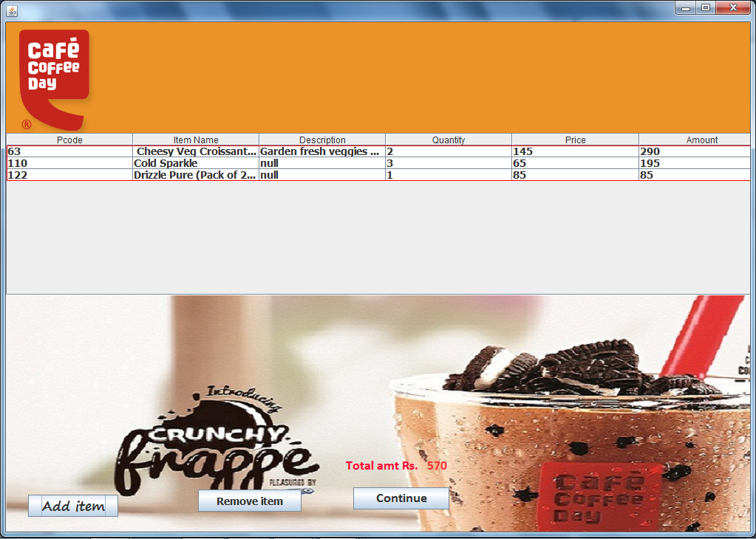

private void jButton9ActionPerformed(java.awt.event.ActionEvent evt) {

jFrame1.setVisible(true);

}

private void jButton5ActionPerformed(java.awt.event.ActionEvent evt)

DefaultTableModel model=(DefaultTableModel)jTable1.getModel();

int aa = jTable1.getSelectedRow();

int s=Integer.parseInt(jLabel41.getText());

if(aa>-1)

{

String a=(String)jTable1.getValueAt(aa,5);

jLabel21.setText(""+a);

int g=Integer.parseInt(jLabel21.getText());

int d=s-g;

jLabel41.setText(""+d);

jLabel30.setText(""+d);

jLabel48.setText(""+d);

model.removeRow(aa);

}

private void jButton10ActionPerformed(java.awt.event.ActionEvent evt)

jFrame3.setVisible(true);

jFrame1.setVisible(false);

Timer t=new Timer(500,new ActionListener()

{

public void actionPerformed(ActionEvent e)

{

z--;

switch(z)

{ case -7:z=10;

case -5:

jLabel18.setIcon(new ImageIcon("D:\\animated coffee\\Cappuccions logo 2_full.gif"));

break;

case 2:

jLabel18.setIcon(new ImageIcon("D:\\animated coffee\\4f02413d01c83.gif"));

break;

case 9:

jLabel18.setIcon(new ImageIcon("D:\\animated coffee\\good_morning_coffee2_8ff98a70379743fe0e76092fef61692b.gif"));

break;

}

}

}

);

t.start();

}

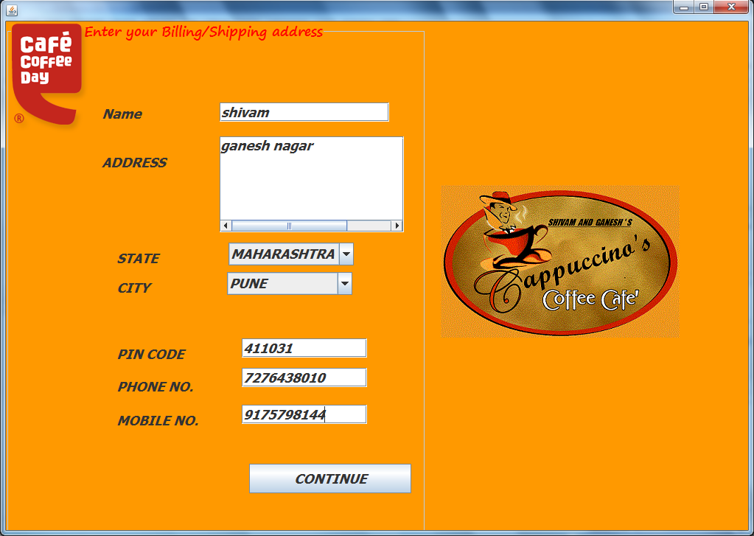

private void jTextField12KeyTyped(java.awt.event.KeyEvent evt) {

// TODO add your handling code here:

String g=jTextField12.getText();

int i=g.length();

if(i>=10) {

evt.consume();

System.out.println("10 digits only");

}

}

private void jTextField11KeyTyped(java.awt.event.KeyEvent evt) {

// TODO add your handling code here:

String f=jTextField11.getText();

int i=f.length();

if(i>=10) {

evt.consume();

System.out.println("10 digits only");

}

}

private void jTextField10KeyTyped(java.awt.event.KeyEvent evt) {

// TODO add your handling code here:

String e=jTextField10.getText();

int i=e.length();

if(i>=6) {

evt.consume();

System.out.println("6 digits only");

}

}

private void jButton11ActionPerformed(java.awt.event.ActionEvent evt)

{ String a=jTextField3.getText();

String b=jTextArea1.getText();

String c=(String)jComboBox3.getSelectedItem();

String d=(String)jComboBox4.getSelectedItem();

String f=jTextField11.getText();

String g=jTextField12.getText();

String e=jTextField10.getText();

jTextArea2.append(" "+a+"\n"+" "+b+"\n "+d+"\n "+c+"\n "+"Pin code "+e+"\n"+" Mobile no. "+f+" / "+g);

jFrame6.setVisible(true);

jFrame4.setVisible(false); }

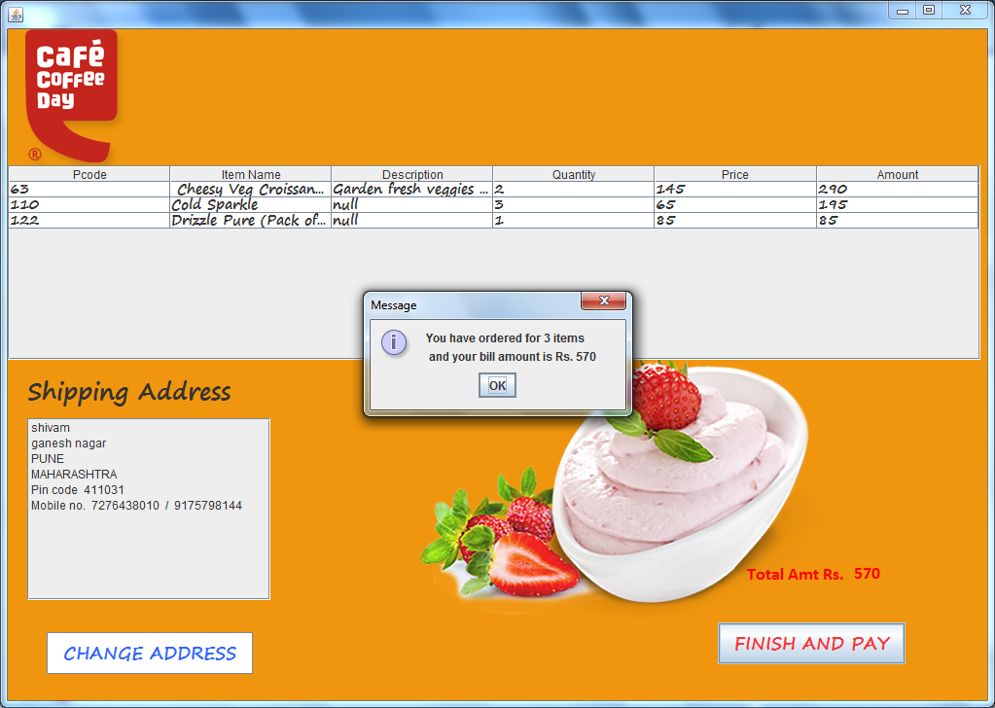

private void jButton3ActionPerformed(java.awt.event.ActionEvent evt) {

jTextField3.setText("");

jTextArea1.setText("");

jComboBox3.setSelectedIndex(0);

jComboBox4.setSelectedIndex(0);

jTextField10.setText("");

jTextField11.setText("");

jTextField12.setText("");

jTextArea2.setText("");

jFrame3.setVisible(true);

}

private void jButton6ActionPerformed(java.awt.event.ActionEvent evt) {

DefaultTableModel m=(DefaultTableModel)jTable2.getModel();

String a=jLabel48.getText();

int c=m.getRowCount();

jOptionPane1.showMessageDialog(null,"You have ordered for "+c+" items \n and your bill amount is Rs. "+a);

jFrame5.setVisible(true);

jFrame3.setVisible(false);

jFrame6.setVisible(false);

}

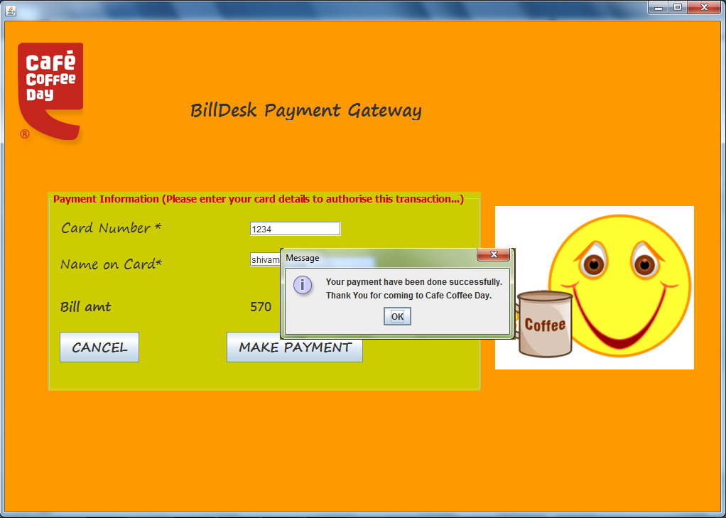

private void jButton7ActionPerformed(java.awt.event.ActionEvent evt) {

System.exit(0);

}

private void jButton8ActionPerformed(java.awt.event.ActionEvent evt)

int c=Integer.parseInt(jTextField2.getText());

String n=jTextField4.getText();

try

{

Class.forName("java.sql.Driver");

con=DriverManager.getConnection("jdbc:mysql://localhost/logid","root","tiger");

stmt =con.createStatement();

String query="select * from pay where cno = "+c+" and cname = "+"'"+n+"';";

rs=stmt.executeQuery(query);

if(rs.next())

{

JOptionPane.showMessageDialog(null,"Your payment have been done successfully."+"\n"+"Thank You for coming to Cafe Coffee Day.");

System.exit(0);

}

else

{

JOptionPane.showMessageDialog(null,"Please enter your card data correctly.");

}

}

catch(Exception e)

{

JOptionPane.showMessageDialog(null,"Error In Connectivity");

}

mysql> use ccd;

Database changed

mysql> select * from ccday;

+-------+----------------------------------+-----------------------------------------------------+-------+------------+

| pcode | item | descp | price | qtyinstock |

+-------+----------------------------------+-----------------------------------------------------+-------+------------+

| 50 | Mango Shot | A Luscious and creamy Alphonso mango delight | 96 | 100 |

| 51 | Belgian Choco Shot | A rich smooth Belgian chocolate shot | 80 | 100 |

| 52 | Veg Samosa | Potatoes and pea cooked in traditional Indian ... | 20 | 100 |

| 53 | Hot and Spicy Chicken Puff | null | 45 | 96 |

| 54 | Chilli Cheese Toast | null | 66 | 87 |

| 54 | Chilli Cheese Toast | null | 66 | 87 |

| 55 | Cookie | Twin packs available in Blackcurrant, Double Choc... | 55 | 96 |

| 56 | Hot and Spicy Veg Puff | Crunchy veggies tossed in spicy sauce, wrapped in... | 98 | 78 |

| 57 | Smoked Chicken Sandwich | Succulent smoked chicken topped with crunchy vegg... | 145 | 100 |

| 58 | Spinach and Corn Cheese Sandwich | null | 120 | 100 |

| 59 | Chicken 65 Sandwich | null | 120 | 100 |

| 60 | Tandoori Paneer Sandwich | Tandoori paneer with chatpata salad, served in a ... | 140 | 120 |

| 61 | Tandoori Paneer Sandwich | null | 150 | 78 |

| 62 | Tandoori Chicken Sandwich | Tandoori chicken with chatpata tomatoes, wrapped ... | 120 | 58 |

| 62 | Tandoori Chicken Sandwich | Tandoori chicken with chatpata tomatoes, wrapped ... | 120 | 58 |

| 63 | Cheesy Veg Croissant | Garden fresh veggies with cheese wrapped in a sof... | 145 | 100 |

| 64 | Tex-Mex-Veg Cheese Sandwich | Veggies tossed in chilli salsa andcheese, wrappe... | 120 | 45 |

| 65 | Black Forest Cup | The classic Black Forest cake served in a cup.... | 130 | 63 |

| 66 | Chocolate Fantasy | null | 120 | 45 |

| 67 | Nutty Fudge Brownie | null | 100 | 67 |

| 68 | Cafe Coffee Day Indulgence | Our signature chocolate cake that oozes indulgenc... | 150 | 30 |

| 69 | Choc-Hola | Rich chocolate cake with scoops ofvanilla ice cr... | 79 | 54 |

| 70 | Black Coffee | null | 70 | 120 |

| 71 | Cafe latte | null | 75 | 45 |

| 72 | Cappuccino | null | 60 | 96 |

| 73 | Chococcino | null | 60 | 96 |

| 74 | Espresso | The original Italian classic-strong dark. | 52 | 20 |

| 75 | Irish Coffee | Coffee, sugar, cream and the smoothflavour of... | 146 | 100 |

| 76 | Macchiato | Espresso's punch smoothened and mellowed by a ... | 123 | 23 |

| 77 | Cafe Mocha | Espresso with hot milk and sinful chocolate sauce... | 78 | 56 |

| 78 | Choco Frappe | More chocolate and ice cream in rich cold coff... | 158 | 25 |

| 79 | Iced Eskimo | Very rich, very cool with a strong coffee edge... | 65 | 89 |

| 80 | Kaapi Nirvana | A prize winner at the WBC in Norway! A chilled... | 152 | 100 |

| 81 | Mochachillo | Rock your world with delicious combination of ... | 178 | 22 |

| 82 | Assam Tea | Only the finest tea leaves from Assam can give... | 189 | 58 |

| 83 | Darjeeling Tea | When a legend enters the French Press, things ... | 89 | 56 |

| 84 | Masala Chai | The Masala Chai is rich, balanced and full of ... | 255 | 21 |

| 85 | Green Jasmine Tea | A Sweet, aromatic and healthy tea.The leaves ... | 75 | 45 |

| 86 | Lemon Iced Tea | Ice cold, lemon flavoured tea, theultimate refre... | 256 | 45 |

| 87 | Pomegranate Lemon | Lemon iced tea with crunchy pomegranate and delic... | 65 | 54 |

| 88 | Cranberry Lemon | Lemon iced tea with cranberry flavour and delicat... | 89 | 44 |

| 89 | Cucumber Lemon | Lemon iced tea with cucumber flavour and a hint o... | 85 | 12 |

| 90 | Choco Rocks | Plunge into the bottomless layersof sinful choco... | 256 | 74 |

| 91 | Black Currant Blast | Black currant flavoured milkshake blended with ic... | 63 | 36 |

| 92 | Cool Blue | Bright blue and tangy ice slush. | 78 | 120 |

| 93 | Lychee Chill | Delight in the lusciousness of lychee in a smooth... | 125 | 50 |

| 94 | Mango Shake | Indulge in this rich, creamy mangoshake. | 156 | 54 |

| 95 | Strawberry Blush | A slushy red strawberry chiller. | 154 | 100 |

| 96 | Snapple | Available in Raspberry Cranberry,Mango madness &... | 45 | 25 |

| 97 | Mushy Mango | Enriched with the goodness of mango, The drink is... | 80 | 30 |

| 98 | Tangy Fushion | This juice is the mishmash of Kiwi,Green apple a... | 120 | 20 |

| 99 | XXX energy drink | Energy bottled in two delicious flavours. | 96 | 8 |

| 100 | Aztec | A delightful American coffee blend.Internatio... | 156 | 56 |

| 101 | Strawberry Lemonade | Luscious strawberry lemonade with flavourful b... | 90 | 47 |

| 102 | Kiwi Lemonade | Zesty kiwi infused lemonade, spicedwith flavo... | 148 | 53 |

| 103 | Classic Lemonade | Refreshing lemonade with a touch ofmint and g... | 189 | 80 |

| 104 | Dark Passion | null | 189 | 80 |

| 105 | Sizzle Dazzle Brownie | null | 75 | 25 |

| 106 | Fruity Blizz | Vanilla Ice Cream cuddled in mango,black currant... | 75 | 25 |

| 107 | Vanilla ice cream | Double scoops. Double delight. | 94 | 47 |

| 108 | Chocolate Ice Cream | Luscious and tempting chocolate ice cream. | 258 | 5 |

| 109 | Chocolate Fantasy Cake | Order from our wide range of delicious cakes and ... | 299 | 2 |

| 118 | Chill-O-Coffee | null | | 50 | 47 |

| 110 | Cold Sparkle | null | | 69 | 12 |

| 111 | Lychee frost tea | null | | 69 | 12 |

| 112 | Strawberry iced tea | null | |69 | 12 |

| 113 | Cold Chocoholica | null | |96 | 45 |

| 114 | Gourmet Hot Chocolate | null | 80 | 54 |

| 115 | Green Apple Soda | null | 60 | 5 |

| 116 | Pome Cherry | null | 60 | 5 |

| 117 | Ethiopian | null | 65 | 8 |

| 119 | Wakecup | null | 67 | 78 |

| 120 | Stovetop Espresso Maker | null | 75 | 78 |

| 121 | Drizzle(Chicory blended coffe... | null | 78 | 98 |

| 122 | Drizzle Pure (Pack of 2) - No... | null | 85 | 47 |

| 123 | Mysore Nuggets Extra Bold | null | 45 | 87 |

| 124 | Indian Kathlekhan Superior | null | 77 | 99 |

| 125 | Cookies | null | 88 | 98 |

| 126 | Chocolates | null | 78 | 100 |

+-------+----------------------------------+-------------------------------------------------------+-------+------------+

mysql> desc ccday;

+------------+--------------+------+-----+---------+-------+

| Field | Type | Null | Key | Default | Extra |

+------------+--------------+------+-----+---------+-------+

| pcode | int(4) | YES | | NULL | |

| item | varchar(50) | YES | | NULL | |

| descp | varchar(100) | YES | | NULL | |

| price | int(20) | YES | | NULL | |

| qtyinstock | int(4) | YES | | NULL | |

+------------+--------------+------+-----+---------+-------+

mysql> use logid;

Database changed

mysql> select * from pay;

+------+--------+

| cno | cname |

+------+--------+

| 1234 | shivam |

| 5678 | ganesh |

+------+--------+

**Bibliography**

This project is made using the analytical data provided by the following reference books and websites:

Web Links:

* [www.google.co.in](http://www.google.co.in)
* www.kesari.in

Books:

ENVIORNMENTAL STUDIES